ADULT REFERRAL FORM |  | 
CONTACT DETAILS
Title * |  | Address *
First Name *
Last Name *
Date of Birth * |  | City *
 |  | County *
Mobile* |  | Eircode
*Preferred date of program: |  | Email
REFERRAL SOURCE
Select area of Referral * |  | Tinnitus |  | Hearing Aid Service
Please expand on the Reason for Referral *

How did you hear about us?
CONSENT

Would you like to receive email updates from Chime Yes No

I consent to Chime holding my personal information
*Client signature _______________________ Date ________________

Please return completed form to: Geraldine.kavanagh@chime.ie

OFFICE USE ONLY
Date received by Chime |  |  |  | Client Profile ID *
Details entered in Salesforce by |  |  |  | Date
Salesforce details checked by |  |  |  | Date
Select area of Referral * | Tinnitus |  | Hearing Aid Service

Chime is compliant with General Data Protection Regulations (GDPR). Full details of our Data Privacy Notice are available at www.chime.ie. Should you have any queries/issues please direct them to dataprotection@chime.ie

Please read each question below carefully. To answer a question, select ONE of the numbers that is listed for that question. Tinnitus Functional Index (TFI) was developed by Meikle and Henry et al (2012) and is recommended to be used in the UK by the NICE guideline 2020. You can use X to fill in the box



- Please complete all questions following based on the past week only

- What percentage of your time awake were you consciously AWARE of your tinnitus?
Never Always
0% | 10% | 20% | 30% | 40% | 50% | 60% | 70% | 80% | 90% | 100%

- How STRONG or LOUD was your tinnitus?
Not At All Extremely
0 | 10 | 20 | 30 | 40 | 50 | 60 | 70 | 80 | 90 | 100

- What percentage of your time awake were you ANNOYED by your tinnitus?
None of the Time All of the Time
0% | 10% | 20% | 30% | 40% | 50% | 60% | 70% | 80% | 90% | 100%

Over the Past week…
- Did you feel IN CONTROL of your tinnitus?
Very Much Never
0 | 1 | 2 | 3 | 4 | 5 | 6 | 7 | 8 | 9 | 10

- How easy was it for you to COPE with your tinnitus?
Very Easy Impossible
0 | 1 | 2 | 3 | 4 | 5 | 6 | 7 | 8 | 9 | 10

- How easy was it for you to IGNORE your tinnitus?
Very Easy Impossible
0 | 1 | 2 | 3 | 4 | 5 | 6 | 7 | 8 | 9 | 10

Over the past week how often did your tinnitus interfere with...
- Your ability to CONCENTRATE?
Did not Interfere Completely Interfered
0 | 1 | 2 | 3 | 4 | 5 | 6 | 7 | 8 | 9 | 10
- Your ability to THINK CLEARLY?
Did not Interfere Completely Interfered
0 | 1 | 2 | 3 | 4 | 5 | 6 | 7 | 8 | 9 | 10

- Your ability to FOCUS YOUR ATTENTION on other things beside your Tinnitus?
Did not Interfere Completely Interfered
0 | 1 | 2 | 3 | 4 | 5 | 6 | 7 | 8 | 9 | 10

Over the past week...
- How often did your Tinnitus make it difficult to FALL ASLEEP or STAY ASLEEP?
Never Always
0 | 1 | 2 | 3 | 4 | 5 | 6 | 7 | 8 | 9 | 10

- How often did your Tinnitus cause you difficulty in getting AS MUCH SLEEP as you needed?
Never Always
0 | 1 | 2 | 3 | 4 | 5 | 6 | 7 | 8 | 9 | 10

- How much of the time did your tinnitus keep you from SLEEPING as DEEPLY or as PEACEFULLY as you would have liked?
Never Always
0 | 1 | 2 | 3 | 4 | 5 | 6 | 7 | 8 | 9 | 10

Over the past week how much has your tinnitus interfered with...
- Your ability to HEAR CLEARLY?
Did not interfere Completely interfered
0 | 1 | 2 | 3 | 4 | 5 | 6 | 7 | 8 | 9 | 10

- Your ability to UNDERSTAND PEOPLE who are talking?
Did not interfere Completely interfered
0 | 1 | 2 | 3 | 4 | 5 | 6 | 7 | 8 | 9 | 10

- Your ability to FOLLOW CONVERSATIONS in a group or at meetings?
Did not interfere Completely interfered
0 | 1 | 2 | 3 | 4 | 5 | 6 | 7 | 8 | 9 | 10

Over the past week how much has your tinnitus interfered with...
- Your QUIET RESTING ACTIVITIES?
Did not interfere Completely interfered
0 | 1 | 2 | 3 | 4 | 5 | 6 | 7 | 8 | 9 | 10

- Your ability to RELAX?
Did not interfere Completely interfered
0 | 1 | 2 | 3 | 4 | 5 | 6 | 7 | 8 | 9 | 10

- Your ability to enjoy "PEACE AND QUIET"?
Did not interfere Completely interfered
0 | 1 | 2 | 3 | 4 | 5 | 6 | 7 | 8 | 9 | 10

Over the past week how much has your tinnitus interfered with...
- Your enjoyment of SOCIAL ACTIVITIES?
Did not interfere Completely interfered
0 | 1 | 2 | 3 | 4 | 5 | 6 | 7 | 8 | 9 | 10

- Your ENJOYMENT OF LIFE?
Did not interfere Completely interfered
0 | 1 | 2 | 3 | 4 | 5 | 6 | 7 | 8 | 9 | 10

- Your RELATIONSHIPS with friends, family and other people?
Did not interfere Completely interfered
0 | 1 | 2 | 3 | 4 | 5 | 6 | 7 | 8 | 9 | 10

- How often did your tinnitus cause you to have difficulty performing your WORK OR OTHER TASKS, such as home maintenance, school work or caring for children or others?
Never had Difficulty Always had Difficulty
0 | 1 | 2 | 3 | 4 | 5 | 6 | 7 | 8 | 9 | 10

Over the past week...
- How ANXIOUS or WORRIED has your tinnitus made you feel?
Not at all Extremely
0 | 1 | 2 | 3 | 4 | 5 | 6 | 7 | 8 | 9 | 10

- How BOTHERED or UPSET have you been because of your tinnitus?
Not at all Extremely
0 | 1 | 2 | 3 | 4 | 5 | 6 | 7 | 8 | 9 | 10

- How DEPRESSED were you because of your tinnitus?
Not at all Extremely
0 | 1 | 2 | 3 | 4 | 5 | 6 | 7 | 8 | 9 | 10

This form can be printed, completed manually and emailed to geraldine.kavanagh@chime.ie or alternatively, you can complete the form online and click the share button (top right of screen ) you will then be directed to the following box.
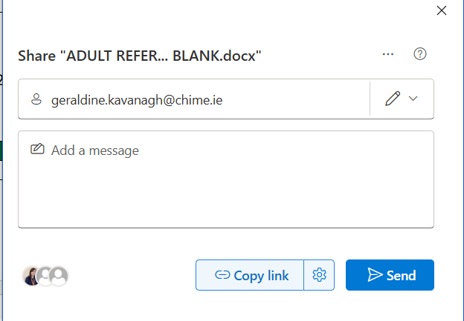

Add email address (geraldine.kavanagh@chime.ie) as per image and click send.

Once we receive your completed registration form, we will send you a zoom link and an information pack by email one week before the program commences. You do not need to contact us.
Unfortunately, we are unable to process registrations if the form is not completed in full and consent is given.

Many thanks for interest in our program and our aim is to support you with your Tinnitus Journey.

Check out our website at www.chime.ie for testimonials from attendees of our previous Tinnitus Toolbox Programs

